Finish | 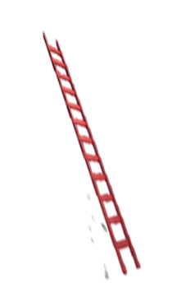  10 ÷ 5 | 3 x 2 | 12 ÷ 4 | 1 x 5
6 ÷ 3 | 5 x 0 | 6 ÷ 2 | 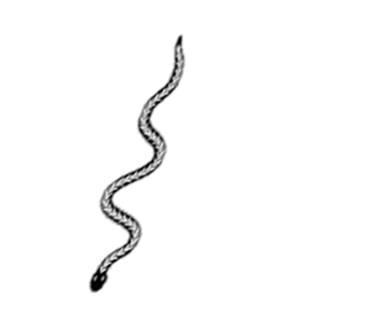  0 x 3 | 10 ÷ 2
3 x 1 | 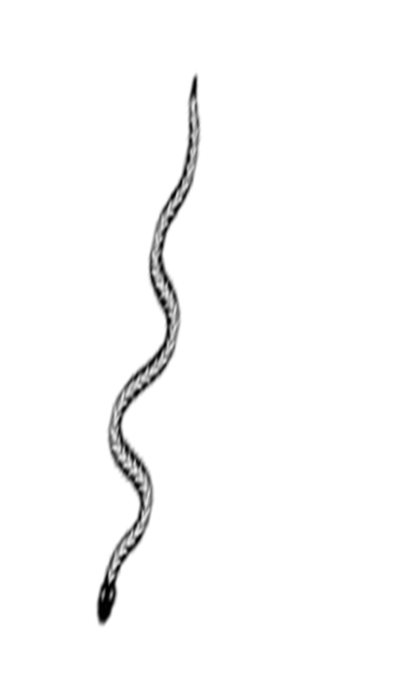  4 ÷ 4 | 4 x 0 | 5 ÷ 5 | 2 x 5
8 ÷ 4 | 12 ÷ 3 | 15 ÷ 5 | 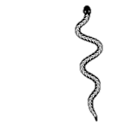  5 x 3 | 20 ÷ 4
16 ÷ 4 | 4 ÷ 2 | 2 x 2 | 3 ÷ 3 | 5 x 5
4 x 4 | 25 ÷ 5 | 8 ÷ 2 | 3 x 5 | 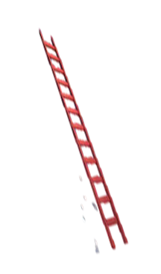  4 x 0
5 x 4 | 3 x 3 | 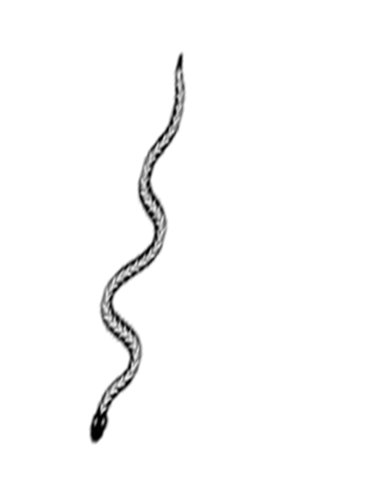  2 ÷ 2 | 2 x 4 | 9 ÷ 3
Start | 5 x 2 | 20 ÷ 5 | 4 x 3 | 15 ÷ 3

